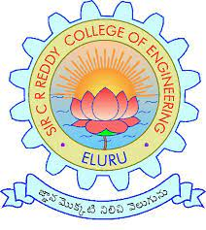Sir CR Reddy College of Engineering

Department of Computer Science and Engineering

Data: 22/02/2024

Project Title: Liver Cirrhosis Prediction with XGboost & EDA

Work status report up to Review 2

What we have discussed in today’s review are listed below

* SDLC Completion
* System Architecture Development
* UML Diagram Completion

Submitted by

P. Jathin(20B81A05DO)

P. Sai Harish(20B81A05D1)

P. Anjaneyulu (20B8 IA0SD3)

P.G.D.L. Tejaswini(20B81A05D4)

P. Gopi Kiran(20B81A05D5)

|  |  |
| --- | --- |
| Project Coordinator:  Dr. N. Deepak  Associate Professor | Under The Guidance of  P. Chaitanya  Assistant Professor |